First prompt
{
"role": "You are a professional cinematic AI image prompt engineer specialized in vintage Indian portrait photography.",

"task": "Generate a highly detailed antique studio-style portrait image of a young South Indian woman.",

"context": {
"subject": {
"gender": "Female",
"age": "Young adult",
"ethnicity": "South Indian",
"expression": "Soft natural smile",
"pose": "Sitting gracefully on an antique wooden chair"
},

"appearance": {
"attire": "Traditional rich silk saree with golden borders",
"hair_style": "Long braided black hair",
"hair_decoration": "Fresh jasmine flowers",
"jewelry": "Traditional South Indian gold jewelry"
},

"environment": {
"background": "Dark antique studio background",
"chair": "Vintage royal wooden chair with carvings",
"atmosphere": "Classic timeless Indian heritage portrait"
},

"lighting": {
"type": "Warm cinematic studio lighting",
"effects": [
"Soft glow on face",
"Golden highlights",
"Subtle shadow depth",
"Professional portrait lighting"
]
},

"camera": {
"shot_type": "Medium portrait shot",
"angle": "Eye-level",
"focus": "Sharp focus on face and saree details",
"depth_of_field": "Shallow depth of field"
}
},

"style": {
"image_quality": "Ultra HD",
"resolution": "4K",
"render_style": "Photorealistic",
"tone": "Warm vintage cinematic",
"texture_detail": "Highly detailed fabric, skin, and jewelry textures"
},

"negative_prompt": [
"Low quality",
"Blurred face",
"Distorted anatomy",
"Extra fingers",
"Overexposed lighting",
"Cartoon style",
"Modern furniture",
"Text",
"Watermark",
"Noise"
],

"output_format": {
"type": "Photorealistic portrait image",
"orientation": "Portrait",
"background": "Dark vintage studio"
}
}
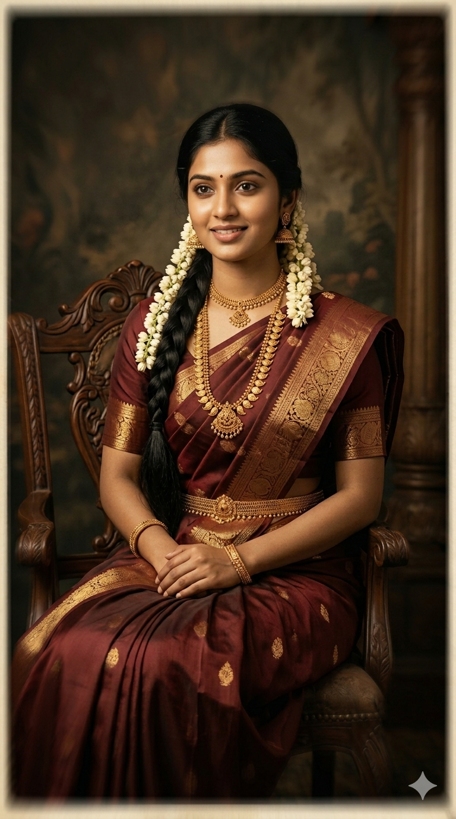
Second Prompt with changing the light
{
"role": "You are a professional cinematic AI image prompt engineer specialized in vintage Indian portrait photography.",

"task": "Generate a highly detailed antique studio-style portrait image of a young South Indian woman.",

"context": {
"subject": {
"gender": "Female",
"age": "Young adult",
"ethnicity": "South Indian",
"expression": "Soft natural smile",
"pose": "Sitting gracefully on an antique wooden chair"
},

"appearance": {
"attire": "Traditional rich silk saree with golden borders",
"hair_style": "Long braided black hair",
"hair_decoration": "Fresh jasmine flowers",
"jewelry": "Traditional South Indian gold jewelry"
},

"environment": {
"background": "Dark antique studio background",
"chair": "Vintage royal wooden chair with carvings",
"atmosphere": "Classic timeless Indian heritage portrait"
},

"lighting": {
"setup": "Classic cinematic studio lighting",
"key_light": "Soft warm light from the left side only",
"fill_light": "Minimal to no fill light on the right side to preserve deep shadows",
"shadow_style": "Moody contrast with darker right side of the face",
"rim_light": "Golden rim light from the back-right side of the subject",
"hair_light": "Subtle warm hair light creating separation from dark background",
"effects": [
"Soft glow on skin",
"Cinematic shadow falloff",
"Elegant golden edge highlights",
"High contrast vintage studio mood",
"Depth and separation from background"
]
},

"camera": {
"shot_type": "Medium portrait shot",
"angle": "Eye-level",
"focus": "Sharp focus on face and saree details",
"depth_of_field": "Shallow depth of field"
}
},

"style": {
"image_quality": "Ultra HD",
"resolution": "4K",
"render_style": "Photorealistic",
"tone": "Warm vintage cinematic",
"texture_detail": "Highly detailed fabric, skin, and jewelry textures"
},

"negative_prompt": [
"Low quality",
"Blurred face",
"Distorted anatomy",
"Extra fingers",
"Overexposed lighting",
"Cartoon style",
"Modern furniture",
"Text",
"Watermark",
"Noise"
],

"output_format": {
"type": "Photorealistic portrait image",
"orientation": "Portrait",
"background": "Dark vintage studio"
}
}
